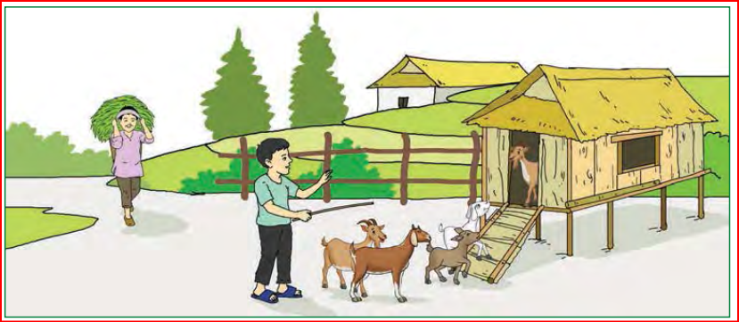kf7\of]hgf ! ;Fu ;DalGwt z}lIfs ;fdfu|L

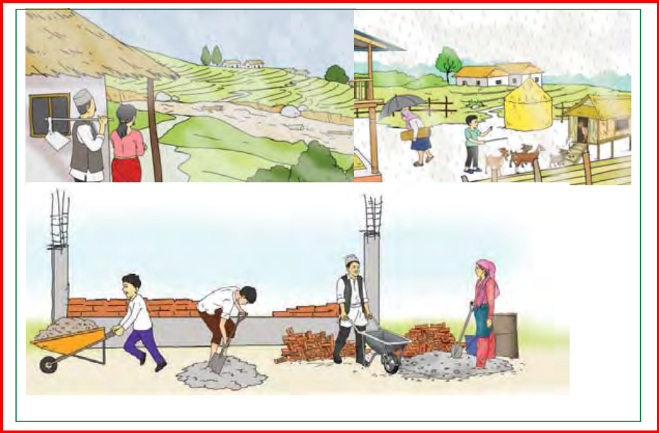

kf7\of]hgf @ ;Fu ;DalGwt z}lIfs ;fdfu|L

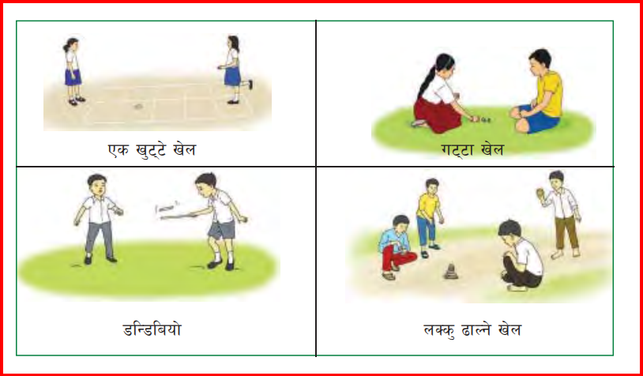

kf7\of]hgf # ;Fu ;DalGwt z}lIfs ;fdfu|L

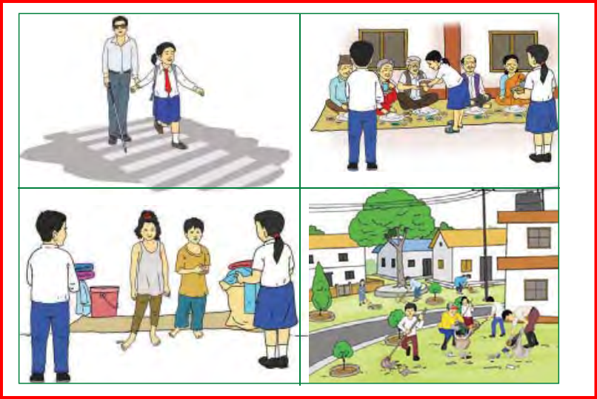

kf7\of]hgf $ ;Fu ;DalGwt z}lIfs ;fdfu|L

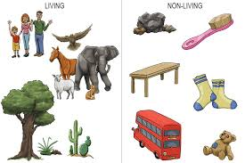

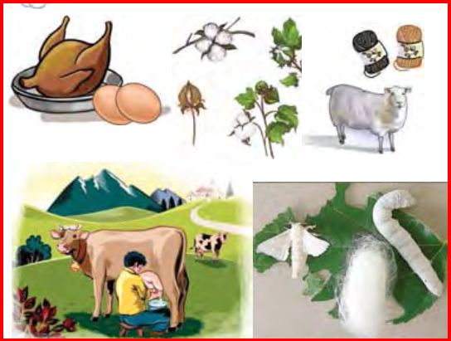kf7\of]hgf % ;Fu ;DalGwt z}lIfs ;fdfu|L

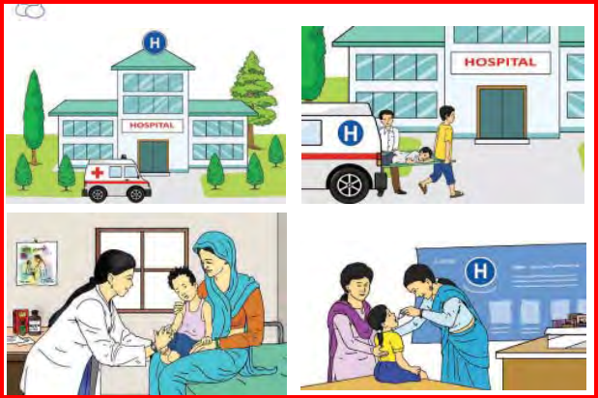kf7\of]hgf ^ ;Fu ;DalGwt z}lIfs ;fdfu|L

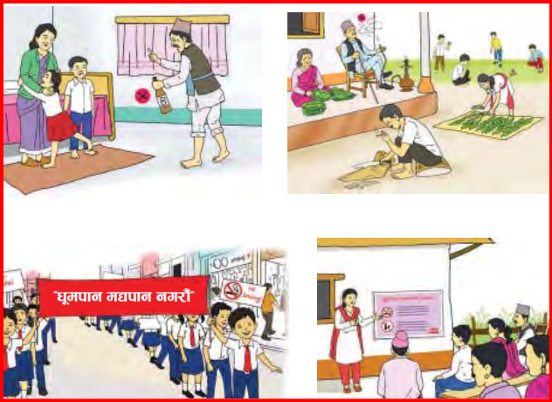kf7\of]hgf & ;Fu ;DalGwt z}lIfs ;fdfu|L

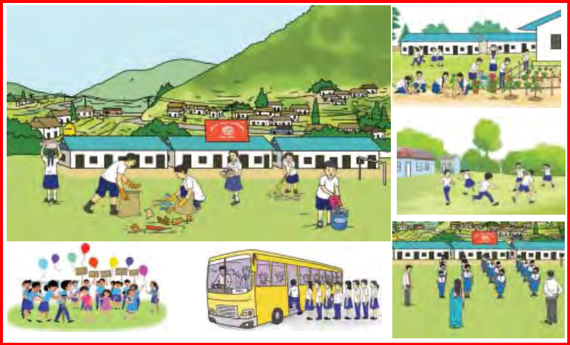kf7\of]hgf \* ;Fu ;DalGwt z}lIfs ;fdfu|L

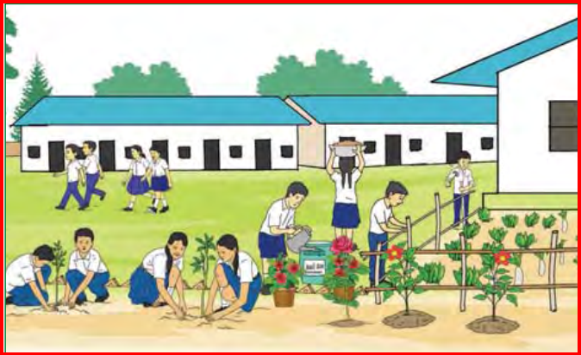

kf7\of]hgf ( ;Fu ;DalGwt z}lIfs ;fdfu|L

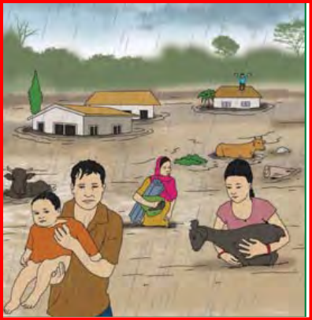

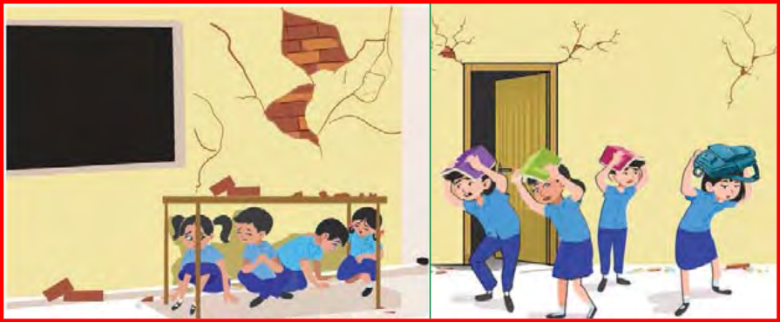

kf7\of]hgf !) ;Fu ;DalGwt z}lIfs ;fdfu|L

